**INTRODUCTION TO COMPUTER NETWORKS**

**LAB 2**

AM.EN.U4AIE22010

ANUVIND M P

**PART 1:**

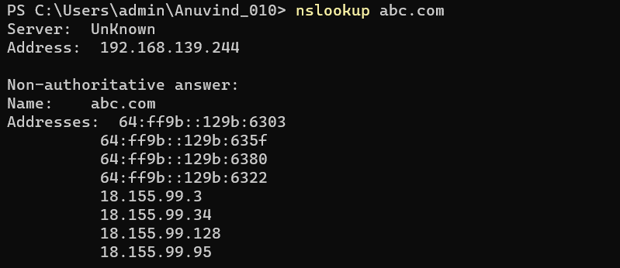

The IP address of abc.com is :

18.155.99.3

18.155.99.34

18.155.99.128

18.155.99.95

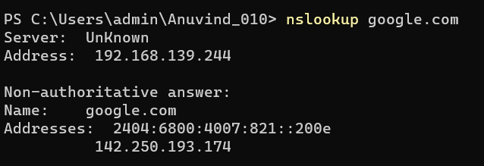

The IP address of google.com is : 142.250.193.174

**PART 2:**

1. Open Packet sniffer [Wireshark] Application and Capture the Wi-Fi/ Ethernet Interface

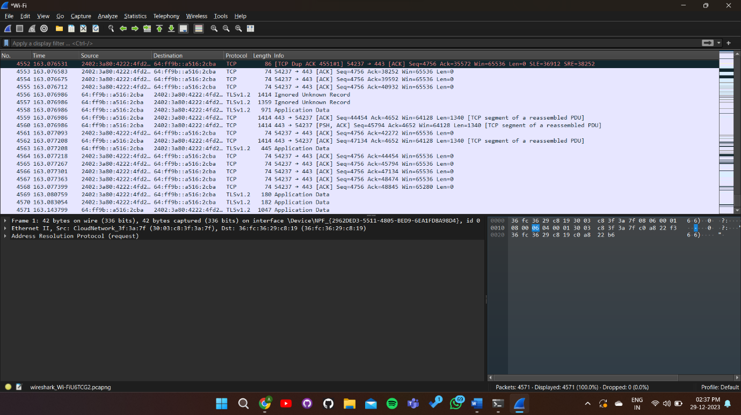

1. Do this activity and capture frames.
   1. Request for a web page by typing the least used URL in the webserver
      * I browsed abc.uk and captured the frames/packets on wireshark

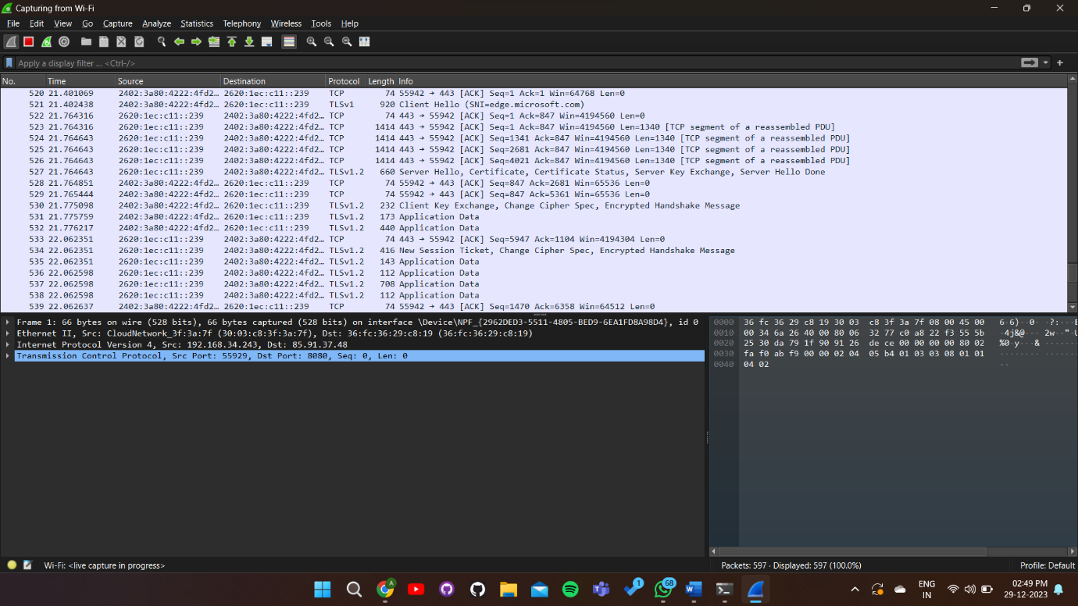

1. Briefly explain the **Encapsulation** process in at least one http request frame of the protocol analyzed. Also complete the table below by PDU contents and details requested in each layer. Also try to provide proof in the form of relevant screenshot

|  |  |  |  |
| --- | --- | --- | --- |
| Layer | Protocol | Important Contents (You can get details on clicking on a packet) | Purpose of the content specified in the Layer |
| Application | HTTP | GET Request for a *given URL* | Initiates a request to retrieve data or resources from a server |
| Transport | TCP | Source and destination port numbers, sequence and acknowledgment numbers, flags (e.g., SYN, ACK) | Ensures reliable data transfer | flow control, and error checking |
| Network | IP | Source and destination IP addresses, routing information | Facilitates logical addressing and routing across networks |
| Data Link | Ethernet | Source and destination MAC addresses, frame type (e.g., IPv4) | Facilitates reliable point-to-point communication within a network |